**LEG Team**



**Users Manual – version 3**

**4/30/2019**

**Game background:**

Players will travel through time and space tunnels into another space world, so that need to avoid obstacles and collect energy for spaceship.

**Introduction:**

This is LEG Team; our game is Beat Runner. Our game is about player controls a character that avoid hitting the coming obstacle. The rule is very simple: there are many different obstacles, player should avoid hitting the stones or other shape of obstacles. The length of the game depends on the background game music. Player need to avoid hit obstacle to get more higher score. Once hit the obstacle the game will end. There one character(ship) and one background map can be chosen now, LEG team are continuing set up more elements for that.

**Menu:**

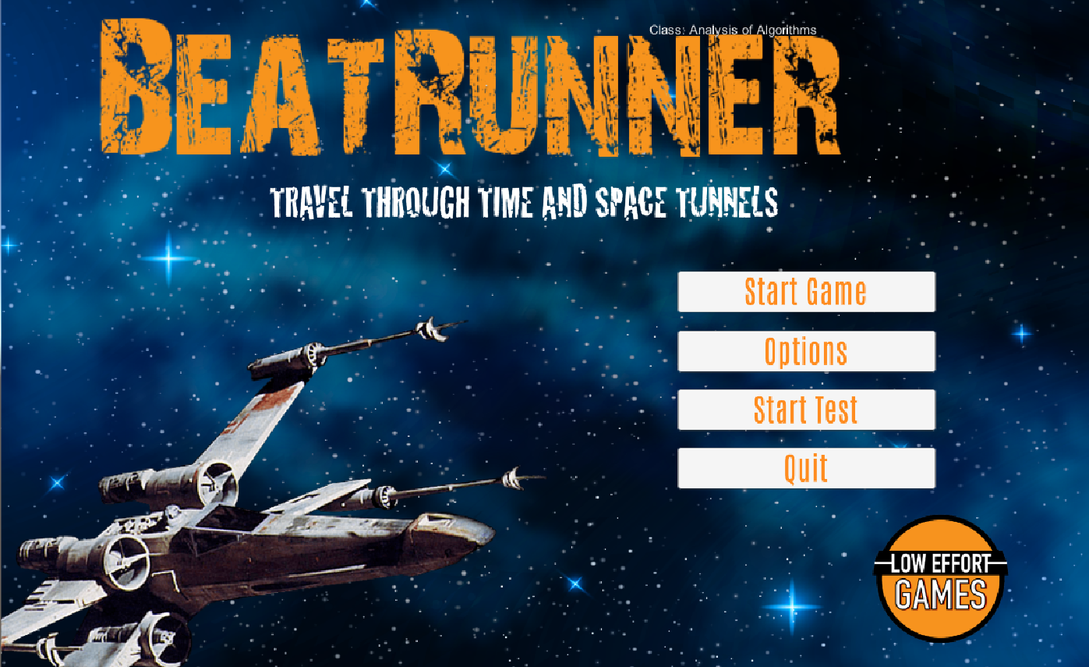

This the menu of the game. For our game, we have three buttons including: start game, options and quit. Player click the “Start Game” to open the game and “Quit” to end the game. For now, there are three different options can be chosen, which are volume, instruction and credits. User can change the setting in the game and see the instruction. When click “Instruction”, there will be open a menu to show to controller which player will be use in the game.

**Character Controller:**

For now, there are four different movements available for character. This is available in “Instruction”.

“A” - Move to left

“D” - Move to right

“Space” - Jump

“S” – Slide(optional)

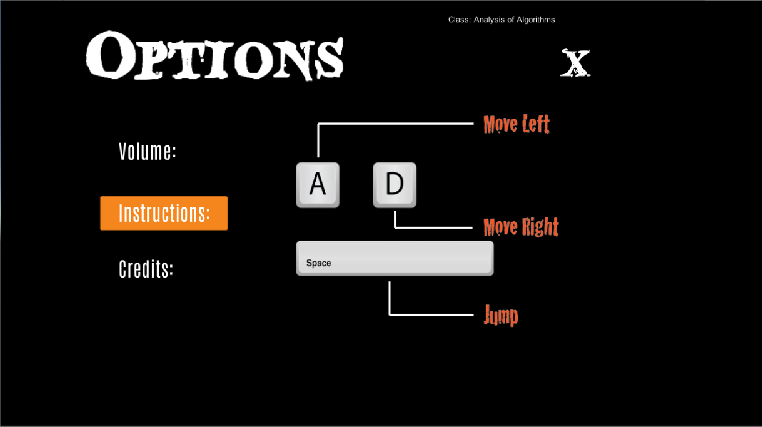

**Difficult selections:**

There are three different choices of difficultly, which is easy, medium and hard. Each of them provides different speed of obstacles come. Easy is slowest and Hard is fastest.

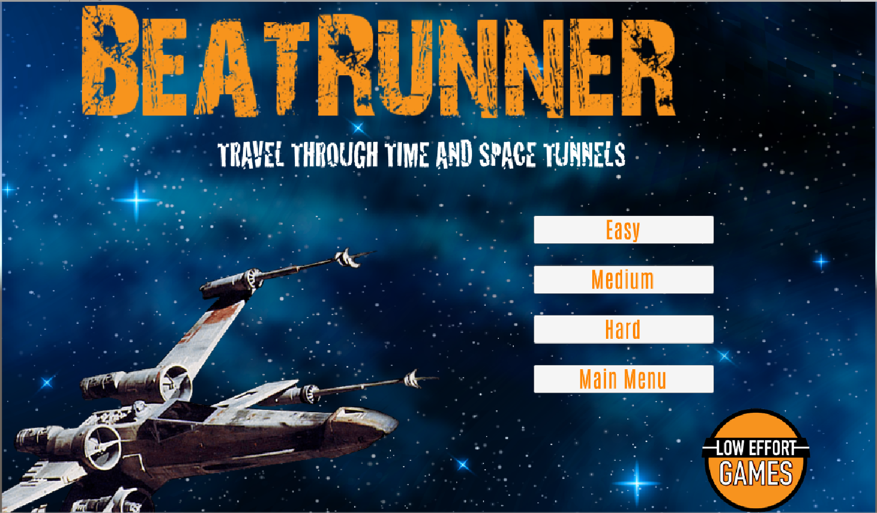

**Game start:**

For our game, the player use keyboard to control the character and the score of the game will display on the upper-left corner of the screen. on the upper right corner of the game there will be two choice one is return to Menu and another is Restart the game. (Don’t click DRBC!!!) 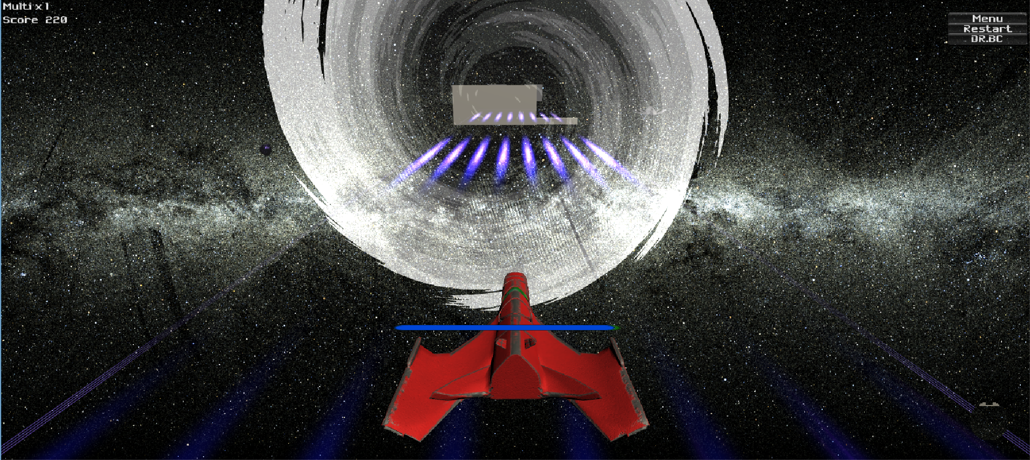

**Game end:**

Once hit the obstacle game will end and player can choose to return to menu and change difficulty to play again.

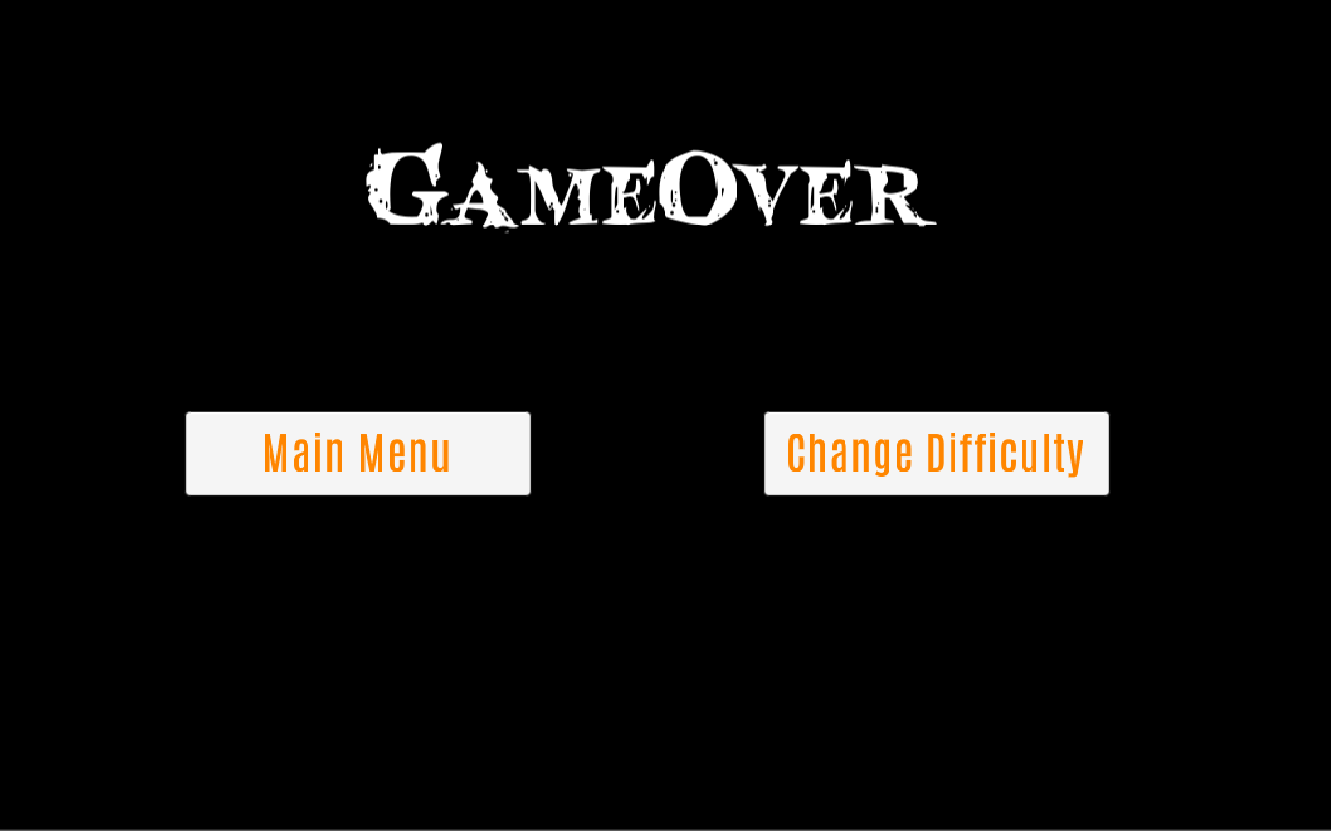

**Music background:**

The sound we use for background in this game is: Never Gonna Give You Up.mp3

The sound we use for hitting obstacle in this game is: CollisionSound.mp3

**Download:**

The game is visible to download in <https://github.com/loweffort/BeatRunner> (the more details information about how to download from GitHub, please view readme.txt)

**Readme.txt:**

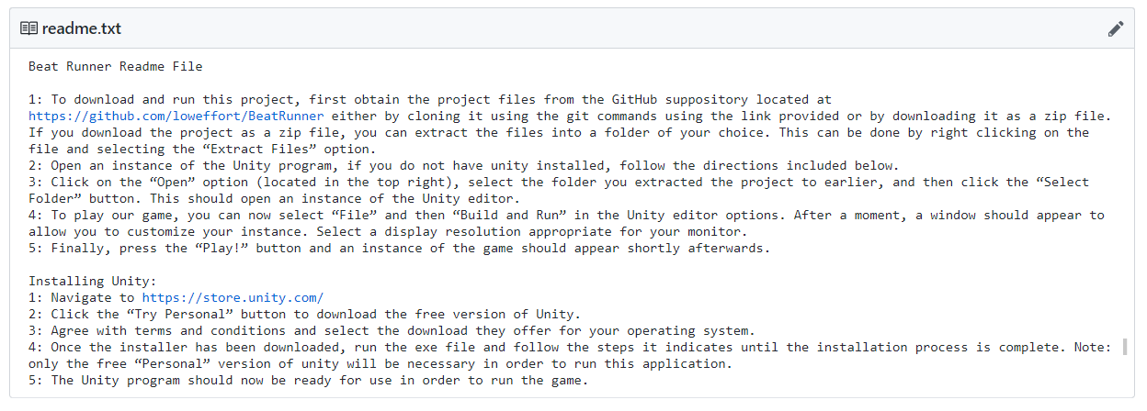

**Installation:**

When going to the main page of our team. Download our game use git clone or download zip file.

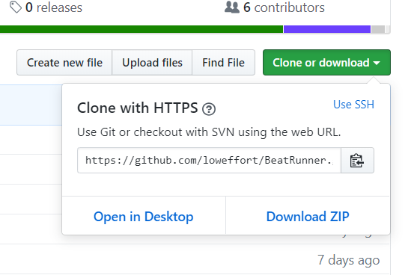

Once download the game success, go to the file: “BearRunnerGame 4-23-19”.

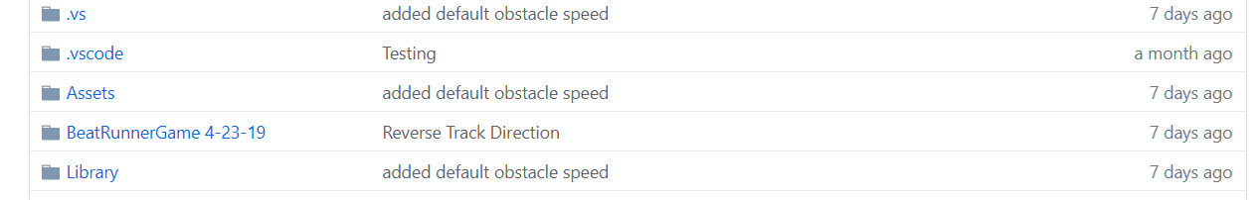

Download the zip file and unzip the file and click “Beat Runner” to open the game.

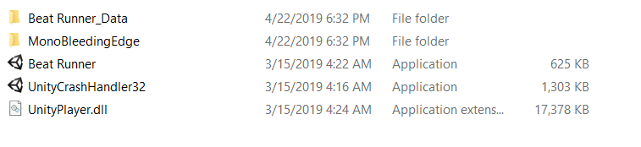

When open the application choose a suitable screen to play the game (1280 * 800 is recommend) and click “Play!” to play.

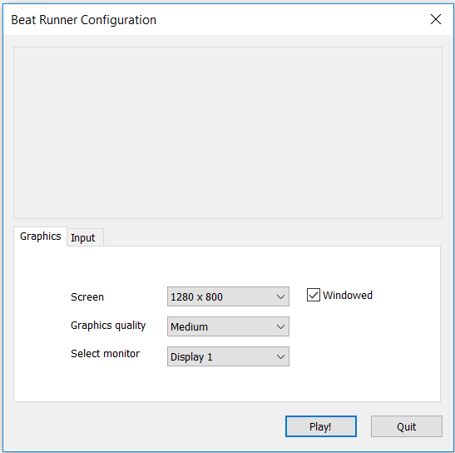

And now start the our game and enjoy!

